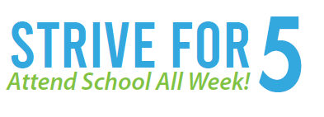
What’s Next?
Improving attendance is a statewide priority! Beginning in FY2027 (2026-2027) ESEA Federal Programs, School Improvement, and District Reading Improvement Plans, as well as DEED issued Requests for Application (RFAs) will include requests for standard attendance plans from districts. This will reduce duplication of efforts for districts and ensure alignment across programs in targeting this goal.
An Easy Start Absenteeism Toolkit and Website will be released in August on the DEED website to assist districts in supporting strong attendance by all Alaska students.
